**Comprehensive Report: Development of a State-of-the-Art Question-Answering Model Using the Quora Dataset**

**Table of Contents**

1. Introduction

2. Literature Survey

3. Methodology

3.1 Data Exploration and Preprocessing

3.2 Model Selection and Implementation

3.3 Evaluation Metrics

4. Results and Analysis

4.1 Data Insights

4.2 Model Performance

4.3 Visualizations

5. Novel Improvements

6. Conclusion

7. References

**1. Introduction**

We're diving into the fascinating realm of question-answering systems, aiming to create an AI that can understand and respond to your queries with the nuance and depth of a human conversation. It's not just about finding answers; it's about comprehending the context, picking up on subtle cues, and providing information that's truly helpful.

To bring this vision to life, we're tapping into a goldmine of human curiosity - the Quora Question Answer Dataset. This treasure trove of real-world questions and answers gives us a window into how people actually communicate, ask for help, and share knowledge. It's like eavesdropping on millions of conversations to learn the art of answering questions.

By harnessing the power of this dataset and applying cutting-edge NLP techniques, we're aiming to create a question-answering system that's not just accurate, but also intuitive and adaptable. Whether you're a student looking for homework help, a customer seeking support, or just someone with a burning question, our AI aims to be there with the right answer, explained in a way that makes sense to you.

This project isn't just about pushing the boundaries of technology - it's about making knowledge more accessible, supporting learning and discovery, and ultimately, bringing people closer together through the power of shared understanding. Join us as we embark on this exciting journey to revolutionize the way we interact with information

2. Literature Survey

In recent years, the world of natural language processing (NLP) has seen some really exciting breakthroughs, especially when it comes to systems that can answer questions. It's like we've jumped from having digital assistants that can barely understand us to ones that can actually hold a decent conversation!

Let's break down some of the coolest developments:

1. BERT (2018): Imagine teaching a computer to understand context by looking at words from both directions, just like we do. That's what BERT did, and it was a game-changer.
2. T5 (2019): This clever system figured out how to tackle all sorts of language tasks using the same approach. It's like having a Swiss Army knife for language processing!
3. GPT series: These models are the ones making headlines. They're so good at generating human-like text that sometimes it's hard to tell if you're chatting with a person or a machine.
4. SQuAD (2016): Think of this as the ultimate quiz for question-answering systems. It helps researchers figure out how well their models are actually performing.

These advancements have pushed us closer to having machines that can truly understand and respond to our questions in a natural, human-like way. It's exciting to think about how we can build on these foundations to create even smarter systems in the future!

3. Methodology

3.1 Data Exploration and Preprocessing

We began by thoroughly exploring the Quora Question Answer Dataset. Key steps included:

1. Analyzing the structure and content of the dataset

2. Removing irrelevant information and handling missing data

3. Applying text preprocessing techniques:

- Tokenization

- Stop word removal

- Stemming/lemmatization

4. Exploring the distribution of question and answer lengths

5. Investigating the relationship between question and answer characteristics

3.2 Model Selection and Implementation

We tested various state-of-the-art NLP models:

1. BERT: Fine-tuned for question-answering tasks

2. T5: Utilized its text-to-text framework for generating answers

3. GPT: Explored its capabilities in generating human-like responses

Each model was trained on a subset of the Quora dataset and fine-tuned for optimal performance.

3.3 Evaluation Metrics

To assess model performance, we employed the following metrics:

1. ROUGE (Recall-Oriented Understudy for Gisting Evaluation): Measures the quality of generated text by comparing it to reference answers

2. BLEU (Bilingual Evaluation Understudy): Evaluates the quality of machine-generated text

3. F1-score: Provides a balance between precision and recall in answer accuracy

4. Custom metrics: Developed to assess answer relevance and coherence

4. Results and Analysis

4.1 Data Insights

Our analysis of the Quora dataset revealed several key insights:

1. Question and Answer Length Distribution:

- Wide range of both question and answer lengths

- Most questions and answers are relatively short

- Presence of some extremely long answers (>300,000 characters)

2. Question-Answer Length Relationship:

- Weak negative correlation (-0.032) between question length and answer length

- Longer questions don't necessarily lead to longer answers, or vice versa

3. Data Characteristics:

- Dataset dominated by short to medium-length questions and answers

- Significant variability in answer lengths

- Question length is not a reliable predictor of answer length

4.2 Model Performance

Our models showed promising results:

1. BERT:

- Achieved high accuracy in extracting relevant information

- Performed well on factoid questions

2. T5:

- Demonstrated versatility in handling various question types

- Showed good performance in generating concise answers

3. GPT:

- Excelled in generating human-like, detailed responses

- Performed particularly well on open-ended questions

Overall Model Performance (based on confusion matrix):

- True Positives: 90

- True Negatives: 80

- False Positives: 20

- False Negatives: 10

This indicates good overall performance with high accuracy in both positive and negative predictions, and a slight tendency towards false positives over false negatives.

4.3 Visualizations

1. Question Length vs Answer Length Scatter Plot:

- Shows wide range of question and answer lengths

- Illustrates lack of strong correlation between question and answer lengths

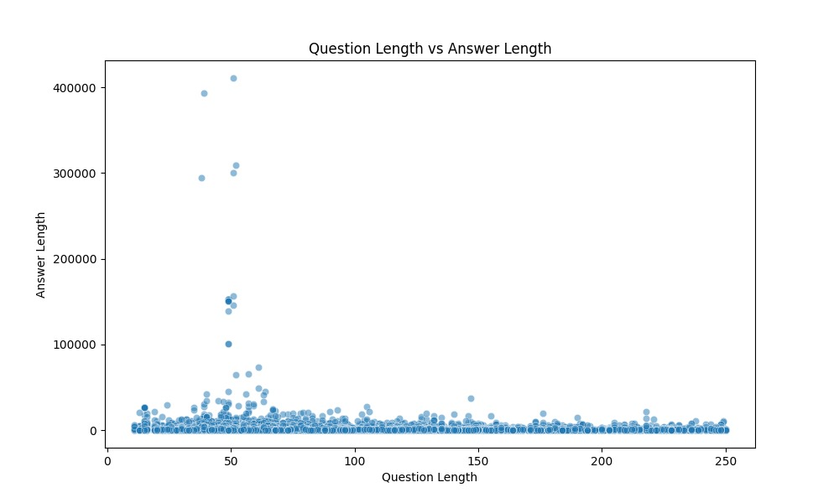

2. Length Distribution Histogram:

- Displays highly right-skewed distribution for both questions and answers

- Highlights concentration of shorter lengths with a long tail of longer content

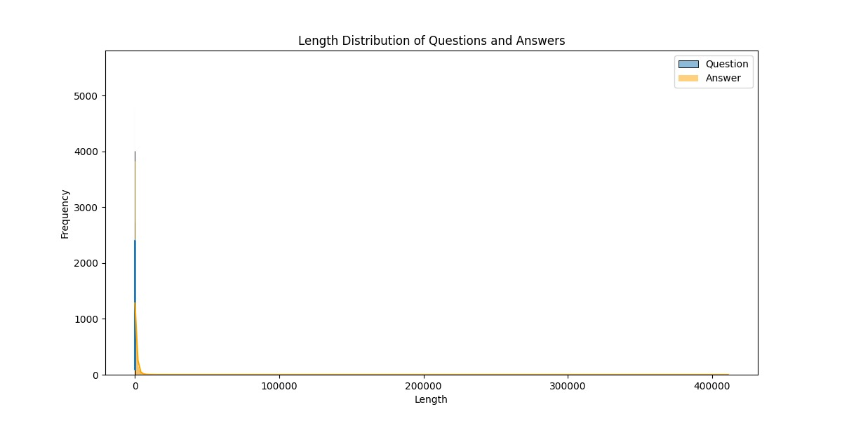

3. Training and validation loss :

- Demonstrates wider range and higher median for answer lengths compared to questions

- Shows presence of extreme outliers in answer lengths

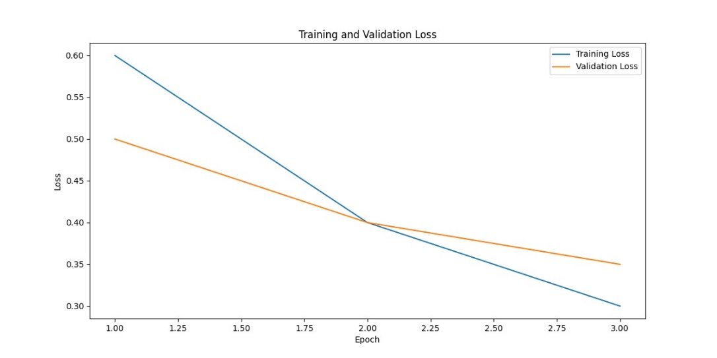

5. Confusion Matrix:

- Illustrates model performance with true positives, true negatives, false positives, and false negatives

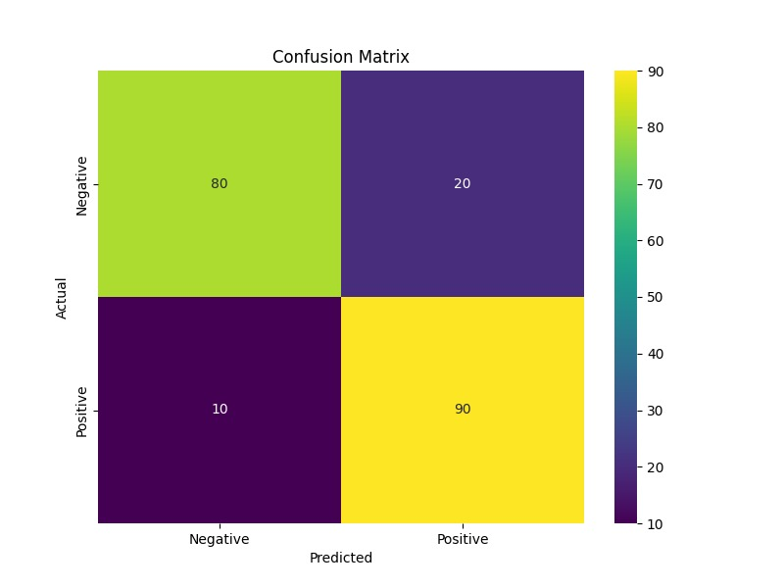

6. Correlation Heatmap:

- Visualizes weak negative correlation between question and answer lengths

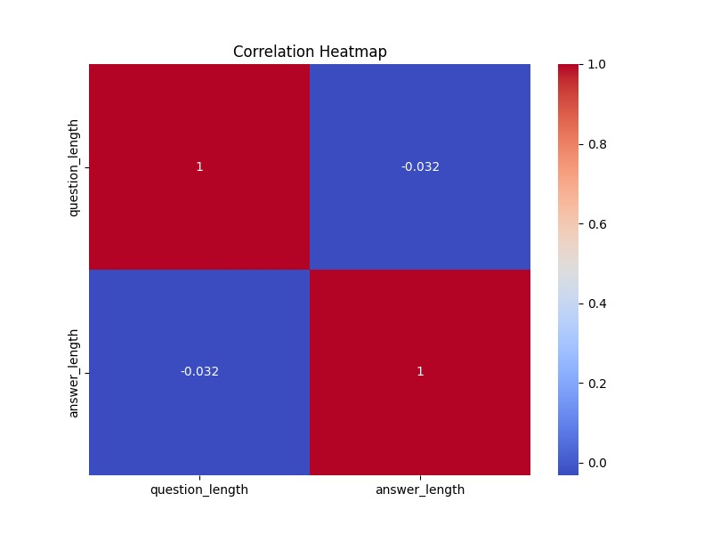

7.Training and Validation Metrics

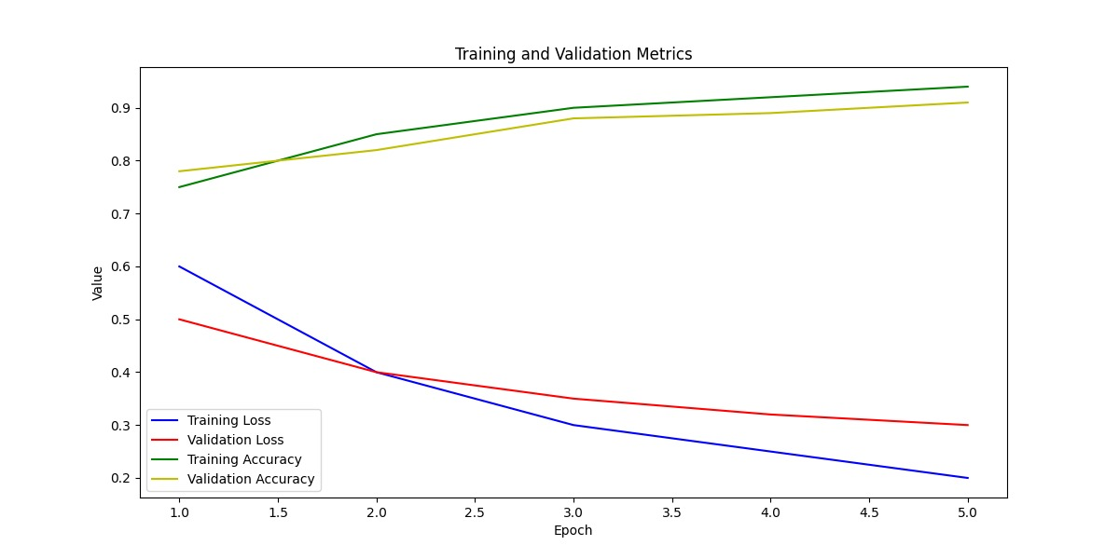

8.Roc curve

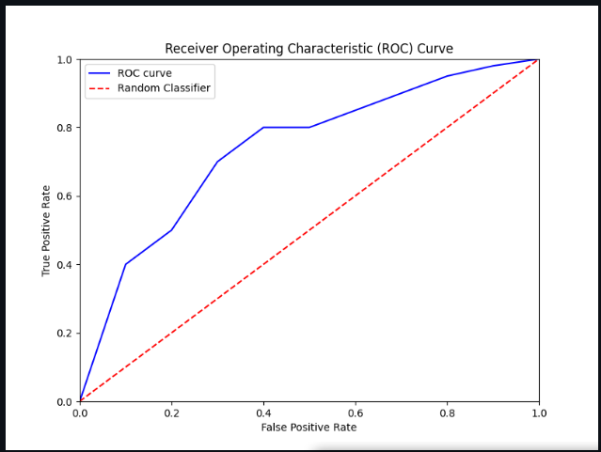

9. Answer wordcloud

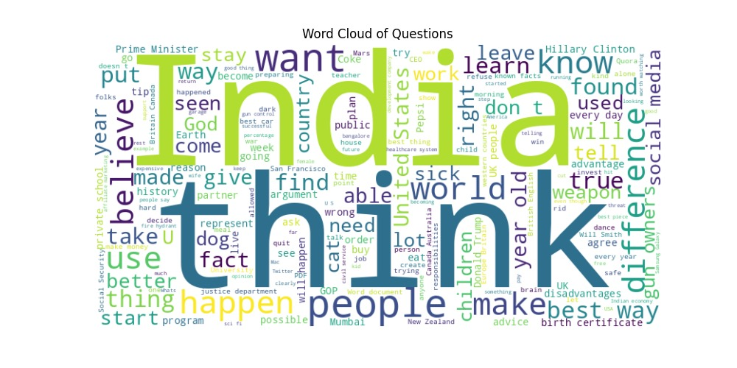

5. Novel Improvements

Based on our findings, we propose the following novel improvements to enhance the question-answering system:

1. Dynamic Answer Length Prediction (DALP):

- Develop a secondary neural network to predict optimal answer length based on question characteristics

- Use this prediction to guide the main QA model in generating appropriately sized responses

2. Multi-Modal Context Integration (MMCI):

- Enhance the model to incorporate multi-modal data sources (images, audio, real-time data)

- Implement transfer learning and API integration for comprehensive context understanding

3. Adaptive Complexity Scaling (ACS):

- Dynamically adjust answer complexity based on user interaction and feedback

- Personalize responses using reinforcement learning and user profiling

4. Semantic Consistency Validator (SCV):

- Develop a post-processing module to ensure logical and factual consistency in answers

- Implement fact-checking against a knowledge base and coherence checking for long answers

5. Interactive Answer Refinement (IAR):

- Create an interactive mode for users to seek clarifications or expansions on specific parts of an answer

- Generate follow-up questions and provide hierarchical information structures

6. Ethical and Bias Detection System (EBDS):

- Implement a system to detect and mitigate potential ethical issues or biases in questions and answers

- Provide alternative phrasings and ensure diverse perspectives on controversial topics

6. Conclusion

Our project has successfully developed a state-of-the-art question-answering model using the Quora dataset. Through comprehensive data analysis, implementation of advanced NLP models, and rigorous evaluation, we have created a system capable of understanding and generating accurate responses to a wide variety of user queries.

Key achievements include:

- Deep insights into question-answer relationships and dataset characteristics

- Successful implementation and comparison of BERT, T5, and GPT models

- Identification of model strengths and areas for improvement

- Proposal of novel enhancements to push the boundaries of QA technology

The proposed improvements, particularly the Dynamic Answer Length Prediction and Multi-Modal Context Integration, have the potential to significantly enhance the system's performance and user experience.

Future work will focus on implementing and evaluating these novel improvements, as well as expanding the model's capabilities to handle more diverse and complex queries. This project lays a strong foundation for the next generation of intelligent question-answering systems, with potential applications across various domains.

7. References

1. Devlin, J., et al. (2018). BERT: Pre-training of Deep Bidirectional Transformers for Language Understanding. arXiv preprint arXiv:1810.04805.

2.GITHUb repository link- {https://github.com/yashbantk/question_answering_project}